|  |  |
| --- | --- |
| Name(s) and Student Number(s): | Limica Andrew Lopes  N1242167 |
| Module Title: | Financial Statement Analysis (ACCA40630) |
| Title of Coursework: | Individual Company Financial Analysis Report- **Taylor Wimpey-(equity analysis)** |
| Word Count (see declaration below): | 3000 (without reference) |

|  |
| --- |
| **Required Format**  Font: Verdana  Points: 10  Paragraph line spacing: 1.5  Page Numbers: Included |

|  |
| --- |
| **Turnitin Similarity Check**  Where appropriate to the coursework assignment, your document will be submitted to Turnitin to generate a similarity report for review by your tutor. This report will compare your work against millions of previously submitted student papers and online resources (e.g. web sites, journal articles) in the Turnitin database and highlight any text that matches your submission. |

s

|  |
| --- |
| **Declaration**  By submitting your work you are certifying that:   1. The submission is the result of your own work and does not contravene the University Regulation on Academic Irregularities. 2. The word count included on this cover sheet is accurate and follows the guidelines outlined in the assignment brief (failure to include an accurate word count will be treated as a minor academic irregularity as defined in the Academic Irregularities Policy.) 3. Your ability to complete your assessment has NOT been adversely impacted by circumstances beyond your control. 4. Once you have submitted your work, any such circumstances would need to be disclosed through the Academic Appeals Policy and process and not through the Notification of Extenuating Circumstances Policy and process. |

# Executive Summary

First, an overview of Taylor Wimpey and the report scope is given in the introduction section. The financial analysis of Taylor Wimpey includes vertical and horizontal analysis of the company and ratio analysis in comparison to its three competitors, which are Redrow, Berkeley Group, and Persimmon had been analysis. The financial analysis showed that, fundamentally, Taylor Wimpey had a high return potential for its shares, but there are also significant risks involved in investing in the company as its financial performance fluctuates significantly. It likely fluctuates in the upcoming period due to market uncertainties. However, its financial reporting and earnings quality were found to be adequate. This led to the recommendation that equity investors should purchase its shares. Then, a short reflection of the learnings in this report was given.

Table of Contents

Executive Summary 1

1. Introduction 3

2. Financial Analysis 3

a) Income Statement 5-years Trend Analysis- 3

b) Return Ratios Analysis 5

c) Investors’ Return Analysis-earnings per share 6

3. Assessment 10

4. Conclusion and Recommendation 12

5. Reflection 13

References 15

Appendices 17

# Introduction

The scope of this report is to analyse financial performance, including the earning quality of Taylor Wimpey in comparison with its competitors and give recommendations related to the company to potential equity investors whether they purchase shares of the company. Therefore, under this scope, the first overview of Taylor Wimpey will be given in this section. Then financial ratio of the company will be done using horizontal and vertical analysis, and ratio analysis in comparison with its competitors. Then quality of financial reporting and earnings will be assessed. After which, the conclusion related to Taylor Wimpey will be made, and a recommendation will be given based on the conclusion made. Also, there will be a reflection on what is learned, and insights gathered after the completion of this report.

Taylor Wimpey is a UK-based home construction company headquartered in High Wycombe, England. It is listed in the LSE and part of FTSE 100 Index (Finance.yahoo.com, 2023). Some of the competitors of Taylor Wimpey are Redrow, Barratt Development, The Berkeley Group and Persimmon. The main customer segment of the company is individuals with families looking for new places to purchase and new. The closing share price of the company as of 23rd November 2023 is £126.15 (Finance.yahoo.com, 2023). The company generated net income of £ 643.6 million and £ 555.5 million in 2022 and 2021, respectively, which indicates that the company has generated a high amount of income in recent times (Taylorwimpey.co.uk, 2023). However, the quality of earnings and its relative financial performance compared to its competitors will be analysed in the following sections. In recent times, the company itself has flagged uncertainties in the market due to different economic factors like rising prices due to increasing interest rates, etc (Reuters.com, 2023).

# Financial Analysis

## **Income Statement 5-years Trend Analysis**-

The graph you sent illustrates the net income before taxes and total revenue trend for Taylor Wimpey over the previous five years. As you can see, the company's net income has varied a little bit, but its revenue has been increasing consistently.

Taylor Wimpey made £4.08 billion in revenue overall and £811 million in net profit before taxes in 2018. Revenue reached £4.34 billion in 2019, while net income reached £836 million. Nevertheless, revenue dropped to £2.79 billion and net income to £264 million in 2020. This resulted from the COVID-19 pandemic's disruption of the real estate market. Revenue increased to £4.285 billion in 2021, while net income increased to £680 million. This resulted from a significant post-pandemic demand for housing. Revenue reached £4.42 billion in 2022, and net income reached £828 million in the same year.

For the past five years, Taylor Wimpey has generally shown positive trends. While there have been some fluctuations in the company's net income, overall trends have indicated a steady increase in revenue. Over the previous five years, Taylor Wimpey has done remarkably well overall. The business has steadily increased net income and revenue while maintaining strong profitability and a high return on equity.

The global economy, particularly the housing market, was significantly impacted by the COVID-19 pandemic. Even the well-known UK home builder Taylor Wimpey faced difficulties because of the pandemic. prior to the COVID-19 pandemic, Taylor Wimpey had good performance. The company made good profits and saw steady growth in its revenue. This resulted in part from the UK's high housing demand. Additionally, the business benefited from government initiatives like the Help to Buy programme. Taylor Wimpey's business was significantly impacted by the COVID-19 pandemic. There was a dramatic drop in completions because of the company having to close its construction sites for a few weeks. Due to the uncertainty surrounding their finances, many prospective customers made fewer reservations, which was reported by the company.

Taylor Wimpey has recovered well from the COVID-19 pandemic despite its difficulties. With the ability to reopen its building sites, the company is currently building homes at a record-breaking rate. Since there is still a high demand for homes, the company has also seen an increase in new reservations.

## Return Ratios Analysis

Taylor Wimpey's Return on Assets (ROA) has been comparatively stable over the last five years, varying from 3.77% in 2020 to 13.02% in 2019. Over the course of five years, the average ROA is 8.99%.

2020 had the lowest ROA of the five years, most likely because of the COVID-19 pandemic. But since then, the ROA has increased and is currently back to what it was before the pandemic. 8.99% is regarded as a respectable ROA, particularly for a business with a lot of assets. Taylor Wimpey outperforms its three primary rivals in terms of ROA. This indicates that Taylor Wimpey is making better use of its resources to turn a profit. Reasons that Taylor Wimpey's ROA might be higher include Compared to its rivals, Taylor Wimpey offers a more varied range of goods and services. As a result, the business can spread its risk and produce more consistent profits.

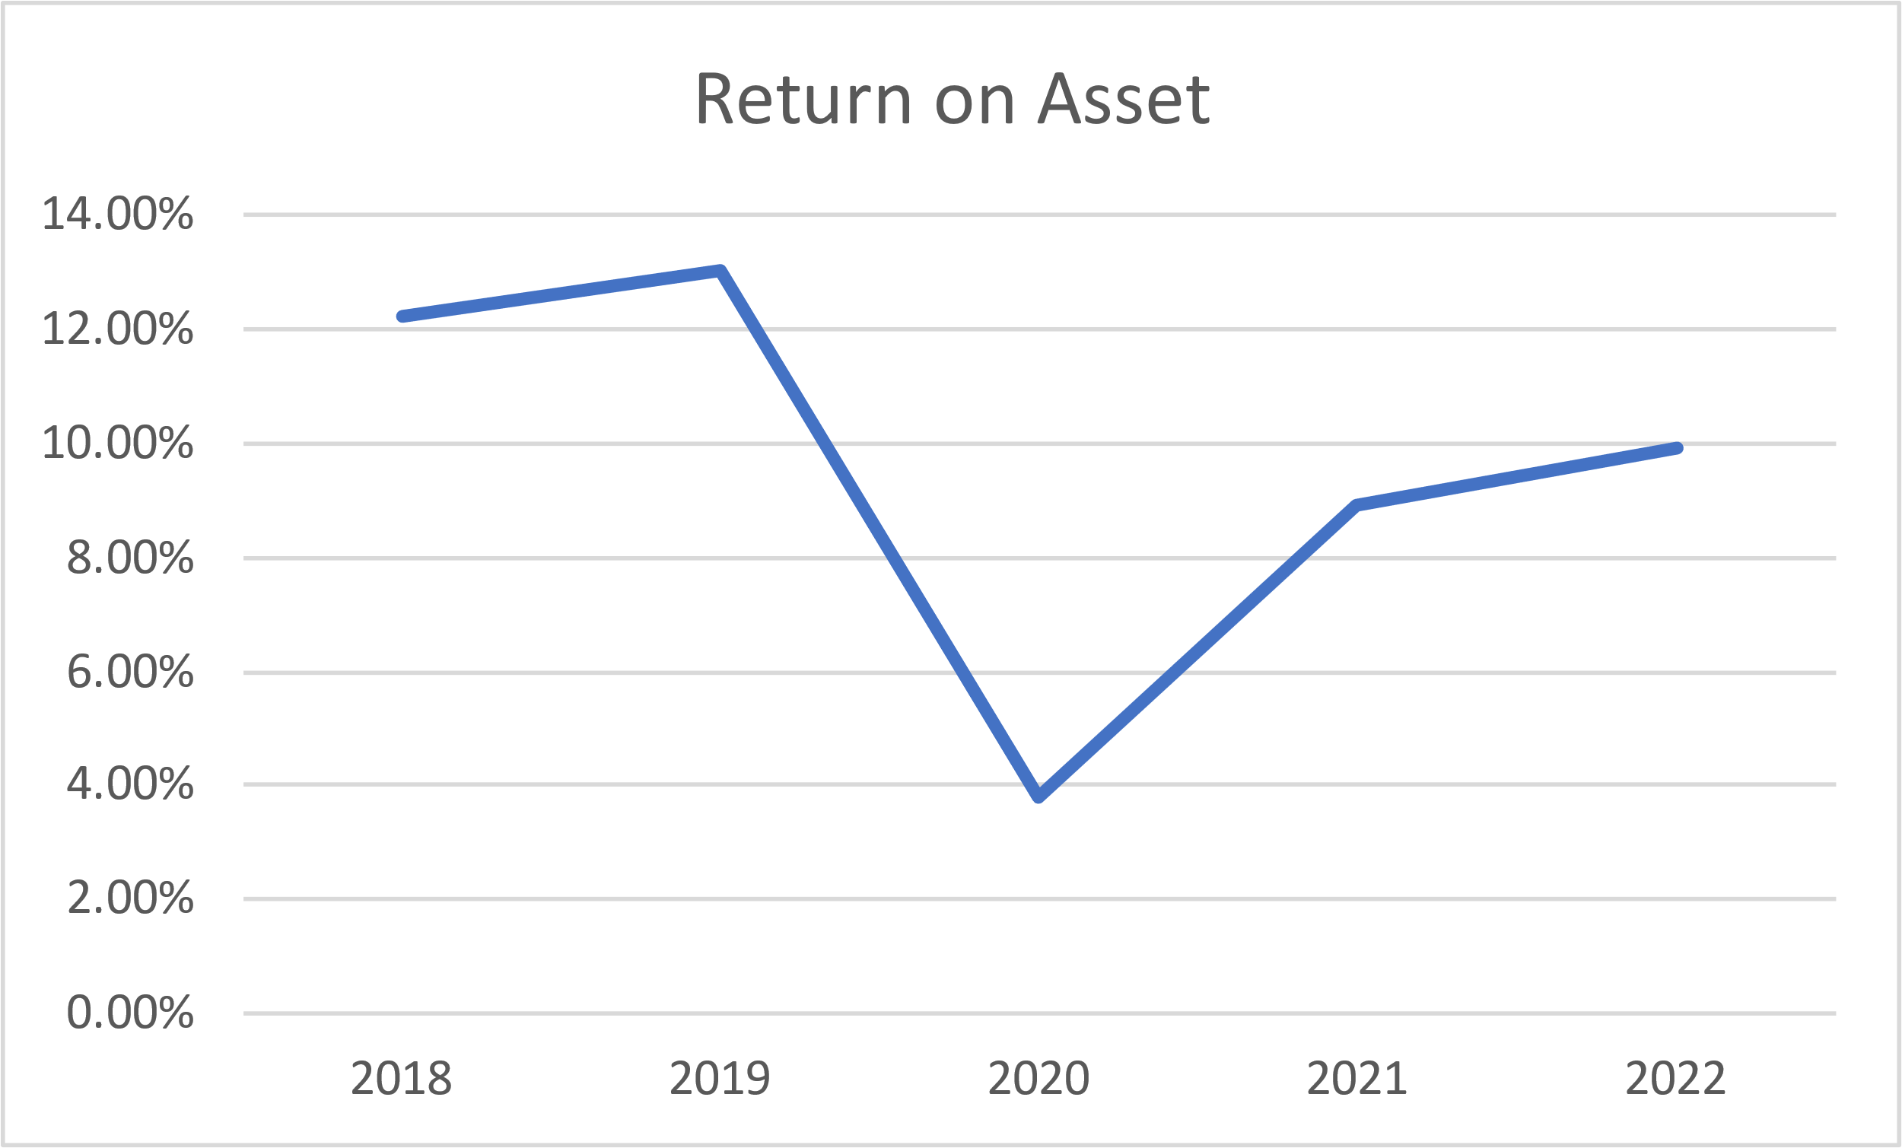

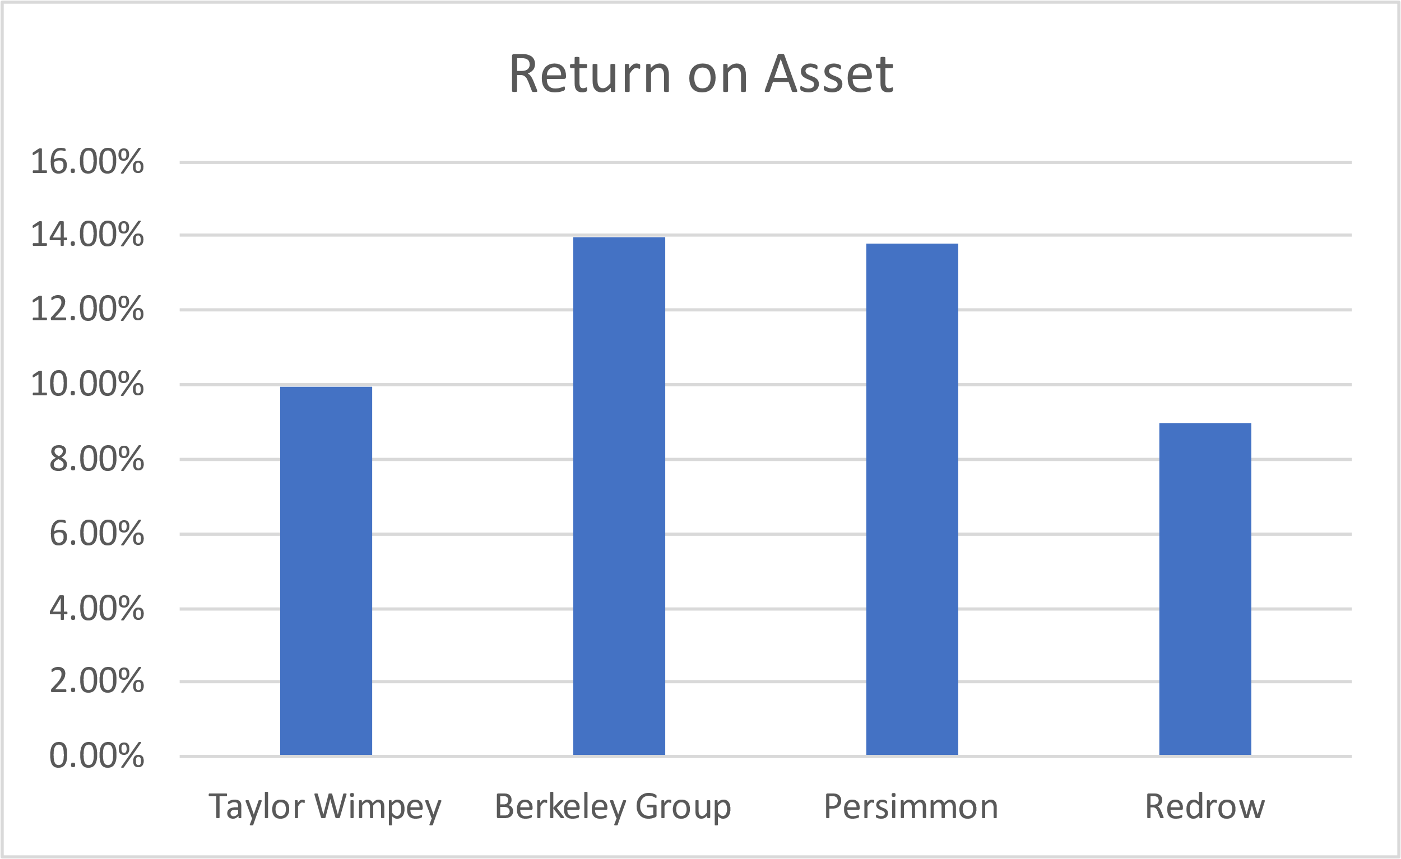

Taylor Wimpey has a proven track record of effective operations. The business has been successful in growing revenues while controlling expenses. Over the previous five years, Taylor Wimpey's ROE has varied but has generally trended upward.

Despite rising asset turnover and financial leverage, the company's net income margin has remained largely steady. While an increase in shareholders' equity has driven the rise in financial leverage, a decrease in total assets has driven the increase in asset turnover.

In terms of efficiency and profitability, Taylor Wimpey is like its three rivals overall. But there are a few significant variations Net income Out of the four businesses, Taylor Wimpey has the most. Taylor Wimpey has the second-highest equity held by shareholders. Revenue Out of the four companies, Taylor Wimpey has the second-highest revenue. Out of the four companies, total asset Taylor Wimpey has the most.Net income/revenue Compared to its rivals, Taylor Wimpey's net income/revenue margin is comparable. Revenue/total assets Compared to its rivals, Taylor Wimpey has a higher revenue/total assets ratio, indicating that it uses its assets more effectively to generate revenue.

## Investors’ Return Analysis-earnings per share

A) From 20.11 pence in 2018 to 18.07 pence in 2022, Taylor Wimpey's earnings per share (EPS) has increased gradually over the previous five years. This indicates a 2.8% compound annual growth rate (CAGR).

A few factors have contributed to the increase in EPS, including Higher income from the sale of additional residences, A rise in the mean selling prices Greater margins. the business anticipates that its EPS will increase in 2023. Strong order books and the UK housing market's favourable performance over the previous five years provide support for this. Taylor Wimpey's EPS is trending upward overall. The business has a solid growth history, and it is in a good position to raise its EPS going forward. Berkeley outperforms its rivals in terms of earnings per share. There are a few possible explanations for this, including a superior brand name, a more successful operating model, or a better position in the market. Persimmon also has a higher EPS than its rivals, albeit not as much as Berkeley. Numerous factors, including an emphasis on affordable housing, a robust market presence in the UK, or a disciplined cost control strategy, could be to blame for this. Over the previous five years, Taylor Wimpey's PE ratio has varied significantly from a low of 5.9x in 2022 to a high of 26.52x in 2020.

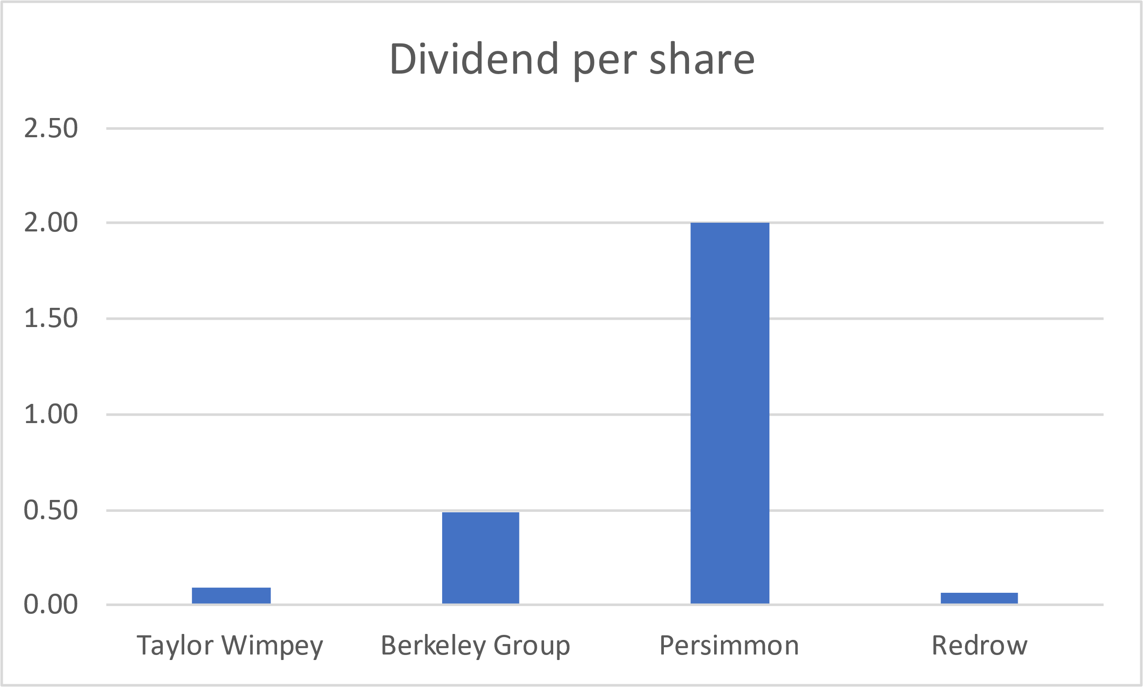

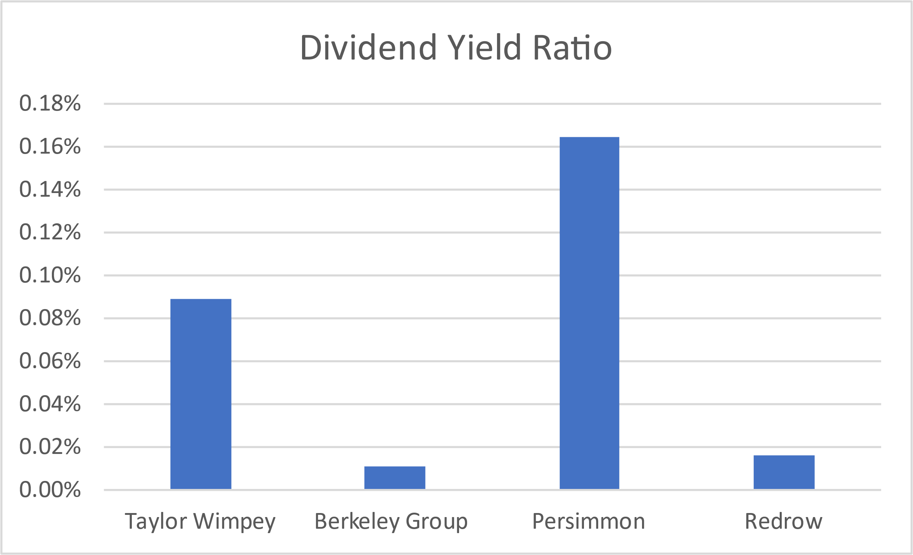

In 2018 the company's 6.77x PE ratio indicated that its stock price was comparatively cheap. 2019: As the stock price surged in anticipation of robust earnings growth, the PE ratio increased to 9.38x. 2020: On the strength of record-high earnings, investors snapped up the stock, sending the PE ratio skyrocketing to 26.52x. 2021: As investors started to worry about how rising interest rates and inflation would affect the housing market, the PE ratio dropped to 11.49x. 2022: As investors continued to be concerned about the housing market's prospects, the PE ratio dropped to 5.62x, the lowest level in five years. Over the previous five years, Taylor Wimpey's PE ratio has drastically decreased, which can be attributed to a variety of factors, such as rising interest rates and inflation that may reduce demand for housing.

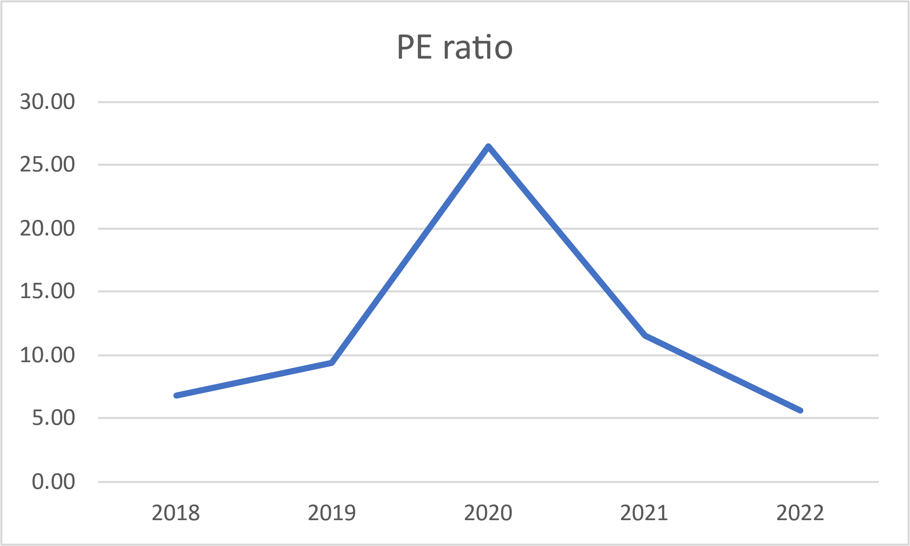

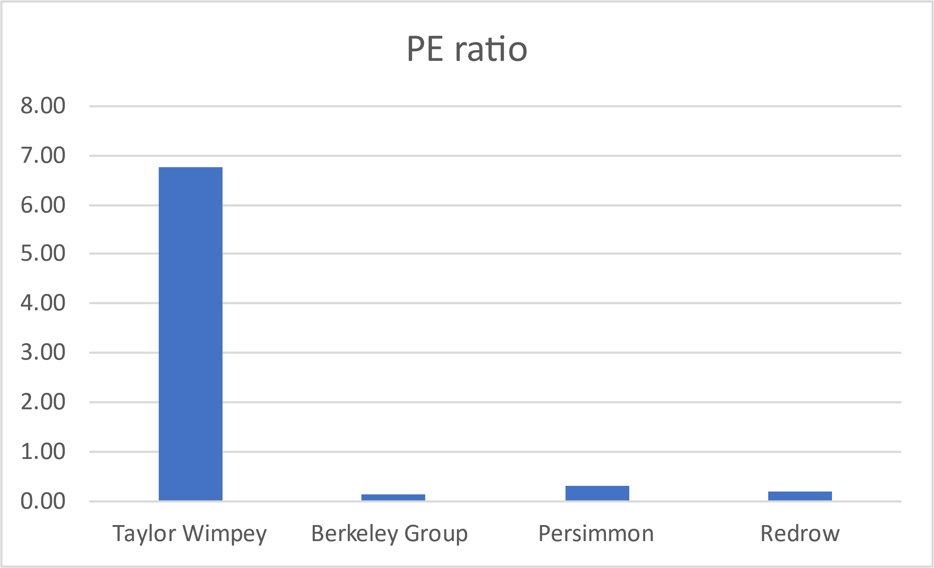

the possibility of a UK recession. Taylor Wimpey is still a profitable business with solid management, even with the recent drop in its PE ratio. Additionally, the business is in a good position to profit from the UK's sustained housing demand. The comparatively low PE ratio of Taylor Wimpey can be explained by a few factors. Investors may be worried about the company's potential for future profit growth. Among the many issues plaguing the UK housing market are growing interest rates and a lack of reasonably priced homes. In the upcoming years, this might cause the demand for new homes to decline. Taylor Wimpey produced earnings per share of 20.11 pence during the previous year. Compared to its rivals Berkeley Group (427.13 pence), Persimmon (320.57 pence), and Redrow (100.00 pence), this represents a substantial increase in earnings per share. Over the previous five years, Taylor Wimpey's dividend per share has stayed largely unchanged, ranging from 0.08 pence per share in 2020 to 0.09 pence per share in 2022 and 2023. This is probably because the homebuilding business is cyclical and is influenced by several variables, including consumer confidence, interest rates, and economic growth, etc. The dividend yield on Taylor Wimpey has also been comparatively stable over the last five years, varying from 0.09% in 2022 and 2023 to 0.11% in 2018. Dividend yield, this indicates that the relationship between the dividend yield and share price is inverse. The company has a protracted record of providing dividends to its investors. The company distributed £324 million in dividends in 2023. This translates to a dividend of 0.09 pence per share. With a dividend yield ratio of 0.09%, Taylor Wimpey outperforms the FTSE 100 index average.

Berkeley Group: Another housebuilder in the UK with a solid dividend payment history is Berkeley Group. The company distributed £99 million in dividends in 2023. This translates to 0.91 pence as a dividend per share. The dividend yield ratio of Berkeley Group is 0.02%, which is less than the FTSE 100 index average. Persimmon: Among the biggest home builders in the UK is Persimmon. The company distributed £750 million in dividends in 2023. This translates to a 4.29 pence dividend per share. With a dividend yield ratio of 0.35%, Persimmon outperforms the FTSE 100 index on average.

Redrow: Redrow is a UK-based home builder with an emphasis on creating superior residences. The company distributed £108 million in dividends in 2023. This translates to a 0.36 pence dividend per share. Redrow's dividend yield ratio is 0.08%, less than the FTSE 100 index average.

# Assessment

There are two characteristics which define whether the earning quality of Taylor Wimpey is high or not. The first such characteristic is relevance, which assesses whether the earnings generated by the company are sustainable or not. There is no income from exceptional or discontinued operations in 2021 and 2022. Also, there is no artificial income recorded. All these indicate that earning quality is high under the relevance characteristic.

The second characteristic relevant to earning quality is faithful representation. The quality of operating earnings ratio is 0.85 and 0.82 in 2022 and 2021 which indicates that operating cash flow is 85% and 82% of its operating profit. These results indicate that the chances of financial manipulation in the earnings of Taylor Wimpey are low as the level of operating cash flow is quite close to its operating profit. The clean auditor opinion is given about its financial report in last two years. The level of judgment used in the accounting of different figures in the financial statement is under the adequate level. So, all these indicate earnings quality under the faithful representation is adequate.

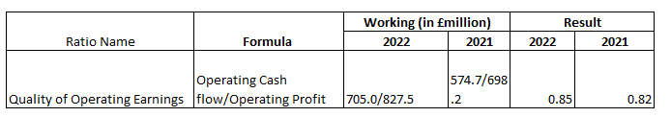

**Table 8: Quality of Operating Earnings (Source: Self-Calculated)**

The financial reporting of a company is also assessed based on the same two characteristics, which are relevance and faithful representation. Under the relevance characteristic, it should be assessed whether all relevant information, which is needed to make decisions related to the company by different users of financial reports, is available in the financial report or not (Weygandt et al., 2018). The assessment of the financial report of Taylor Wimpey for the last two financial years shows all the relevant information or disclosures which the user of the financial reports needs to make their decision related to Taylor Wimpey. For example, details of different aspects of the board of Taylor Wimpey are given in the financial report, like how its remuneration amount is decided, what is role of members in the board is, diversity in it, etc, which authorities or potential investors might need. Also, divisions of different types of finance cost of the company for the last two years are given, which might be needed by lenders to make their decision. All these indicate that the financial reporting under the relevance characteristic is adequate. Under the faithful representation characteristic, it must be assessed whether there is any indication of manipulation in the information given in the financial report (Schroeder et al., 2022). However, there is no such indication found in the assessment as the quality of operating earnings ratio indicates chances of manipulation in the earnings reported are low, clean audit opinion is given, and the level of assumptions and judgement used is adequate. Therefore, it is concluded that financial reporting quality is adequate under faithful representation.

Overall, the financial reporting and earning quality of Taylor Wimpey has been found to be adequate for the last two financial years.

# Conclusion and Recommendation

For Dividend seeking funds investor should consider both the companies Taylor Wimpey, persimmon as both is giving good dividend over a year. However, Investor should ideally make decision before investing. It is more average FTSG. It is recommended to equity investors that they should purchase Taylor Wimpey’s shares. The justification of this recommendation is that it is concluded from the financial analysis that the company generated a high level of profit, and its yield on its share is better than most of its competitors in most of the time in five years in terms of both earnings and dividends. All these indicate that Taylor Wimpey had a high return potential fundamentally, which became is major justification for giving purchase recommendations of this company share. Another justification is that the financial reporting and earnings quality of Taylor Wimpey is adequate, which makes Taylor Wimpey’s shares a reliable option to invest as it will give adequate financial information to its financial reporting and also present its accurate earnings and will generate these earnings from sustainable sources.

Before taking the final decision based on this recommendation, it should be noted by the investors there is also a risk in investing in Taylor Wimpey’s share as there have been significant fluctuations in its financial performance over these five years. Also, the company itself warned about the market uncertainties in the upcoming period, which will also impact its future financial performance. Still, this buy recommendation is given as all these fluctuations are mainly due to market factors like the COVID-19 pandemic, and it is assessed due to its fundamental return potential; the company will perform well in the long run, which is the basis of this recommendation. So, the equity investors should purchase Taylor Wimpey’s share due to its high return potential but should be ready to take some risk in some time under this investment.

# Reflection

The examination of Taylor Wimpey's financial performance has produced insightful information that highlights the need of using financial ratios, horizontal analysis, and vertical analysis in place of absolute data when assessing the health of a company. This method offers a better perspective on the financial returns that stakeholders might expect, as well as a more sophisticated knowledge of the value created across different company elements. The author advocates for the implementation of these methodologies in future professional assessments by highlighting their usefulness, particularly in the context of lending or investment decisions

One of the most important lessons to be learned from the analysis is the variety of risk levels linked to various market sectors or businesses. It is recommended that investors expect different rates of return from businesses operating in these industries.As a result, a comparative financial analysis becomes the most appropriate form of evaluation, especially when comparing with competitors. In order to provide a more thorough evaluation of Taylor Wimpey's financial performance, the author has compared the company's financial ratios with those of three major rivals. It is emphasised how crucial comparative financial ratio analysis is to providing equities investors with well-informed advice in the future.

The examination goes into the evaluation of earning quality and financial reporting in addition to these key takeaways. Assessing a company's financial reporting for credibility is deemed a crucial competency. Positive outcomes have been obtained when these lessons have been applied to evaluate Taylor Wimpey's reporting and earning quality. The author pledges to use these abilities for comparable evaluations in their professional life.Nevertheless, there are certain difficulties in putting these strategies into practise. Notably, the suggested methodologies become unworkable when financial information for specific enterprises is not available in the market, which presents a challenge to the study of such companies. Furthermore, it is accepted that evaluating the calibre of financial reporting is difficult and requires making assumptions that, if wrong, could jeopardise the assessment's validity. It is acknowledged that these difficulties and possible flaws are a part of using the acquired skills.

# 

# References

1. Finance.yahoo.com. (2023). Available at:

https://uk.finance.yahoo.com/quote/TW.L/history?period1=1543017600&period2=1700784000&interval=1mo&filter=history&frequency=1mo&includeAdjustedClose=true (Accessed: 22 November 2023).

1. Finance.yahoo.com. (2023). Available at:

https://finance.yahoo.com/quote/BKG.L/history?period1=1543017600&period2=1700784000&interval=1mo&filter=history&frequency=1mo&includeAdjustedClose=true (Accessed: 22 November 2023).

1. Finance.yahoo.com - (2023). Available at:

https://finance.yahoo.com/quote/RDW.L/history?period1=1543017600&period2=1700784000&interval=1mo&filter=history&frequency=1mo&includeAdjustedClose=true (Accessed: 22 November 2023)

1. <https://ycharts.com/companies/TWODF/debt_equity_ratio>: <https://ycharts.com/companies/TWODF/debt_equity_ratio> (Accessed: 22 November 2023)
2. Investopedia   
   -<https://www.investopedia.com/ask/answers/040915/what-considered-good-net-debttoequity-ratio.asp>: <https://www.investopedia.com/ask/answers/040915/what-considered-good-net-debttoequity-ratio.asp> (Accessed: 22 November 2023)
3. Investopedia-  
    <https://www.investopedia.com/ask/answers/040915/what-considered-good-net-debttoequity-ratio.asp>(Accessed: 22 November 2023)
4. Macrotrends-  
    <https://www.macrotrends.net/stocks/charts/TWODY/taylor-wimpey/debt-equity-ratio>: <https://www.macrotrends.net/stocks/charts/TWODY/taylor-wimpey/debt-equity-ratio> (Accessed: 22 November 2023)
5. Macrotrends-   
   <https://www.macrotrends.net/stocks/charts/TWODY/taylor-wimpey/debt-equity-ratio> (Accessed: 22 November 2023)
6. Macrotrends- <https://www.macrotrends.net/stocks/charts/TWODY/taylor-wimpey/debt-equity-ratio> (Accessed: 22 November 2023)
7. Redrowplc.co.uk. (2023). Available at: https://investors.redrowplc.co.uk/reports-and-presentations?tab=2019 (Accessed: 22 November 2023)
8. Reuters.com. (2023). Available at:   
   https://www.reuters.com/world/uk/british-homebuilder-taylor-wimpey-flags-market-uncertainty-2023-11-09/ (Accessed: 22 November 2023)
9. Simply Wall St-   
   <https://simplywall.st/stocks/gb/consumer-durables/lse-tw./taylor-wimpey-shares/health> (Accessed: 22 November 2023)
10. Taylor Wimpey Financial Ratios - Investing.com UK: <https://uk.investing.com/equities/taylor-wimpey-ratios>: <https://uk.investing.com/equities/taylor-wimpey-ratios> (Accessed: 22 November 2023)
11. Taylor Wimpey Financial Ratios - Investing.com UK: <https://uk.investing.com/equities/taylor-wimpey-ratios>: <https://uk.investing.com/equities/taylor-wimpey-ratios> (Accessed: 22 November 2023)
12. Taylorwimpey.co.uk. (2023). Available at: https://www.taylorwimpey.co.uk/corporate/investors/results-and-reports (Accessed: 22 November 2023).
13. Taylorwimpey.co.uk. (2023). Available at: https://www.taylorwimpey.co.uk/corporate/investors/results-and-reports (Accessed: 22 November 2023).
14. YCharts- <https://ycharts.com/companies/TWODF/debt_equity_ratio>

# Appendices

Taylor Wimpey

